**UŁÓŻ NAZWY ZWIERZĄT Z LITER**

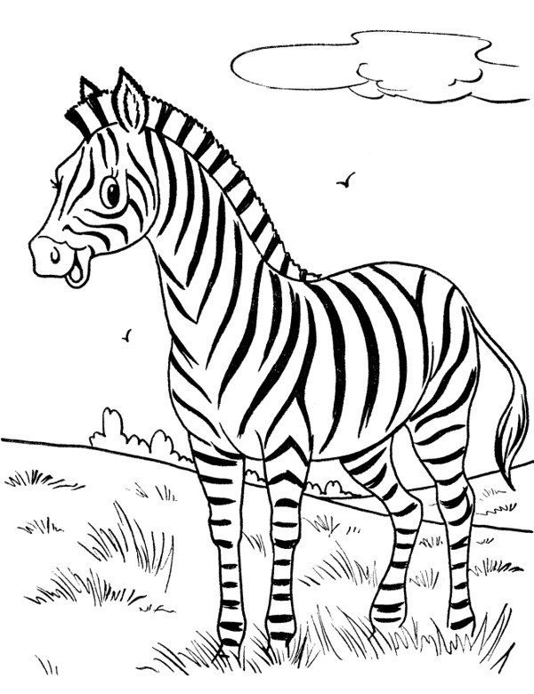

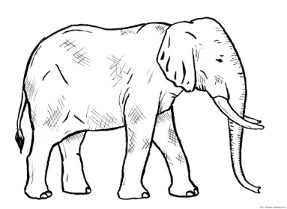

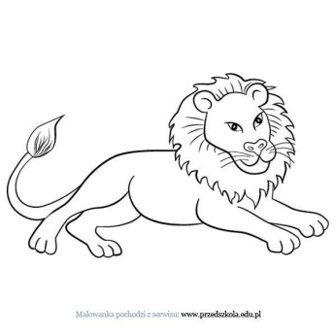



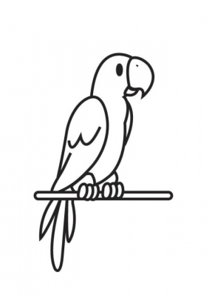

|  |  |  |  |  |  |  |  |
| --- | --- | --- | --- | --- | --- | --- | --- |
| **m** | **z** | **p** | **o** | **b** | **ń** | **e** | **w** |
| **e** | **s** | **ł** | **a** | **a** | **r** | **a** | **p** |
| **a** | **l** | **ł** | **p** | **u** | **g** | **a** |  |